ENGLISH
Information Sheet – High-Quality Rebar Supply + Our Products
COTI commercial interface – Algerian manufacturing origin
1. Our Profile
• Status : Commercial interface and industrial supply coordination. COTI is not the manufacturer.
• Manufacturing origin : Algeria; products from an integrated steelmaking complex.
• Industrial capacity : 2 million tonnes per year of long products: 1.5 million tonnes of rebar and 0.5 million tonnes of wire rod. These are stated installed capacities, not verified annual output or stock reserved for COTI.
• Visits : COTI is available to arrange your reception at the plant for verification, a technical visit or a commercial meeting, by appointment and subject to site approval.
2. Product Range
Rebar (Reinforcing Steel Bars) – Straight Bars
• Grades : 500 MPa-class steel; B500B / B500C or another documented grade according to the market, standard and confirmed offer.
• Diameters : 8, 10, 12, 14, 16, 20, 25, 32 and 40 mm. Special sizes between 8 and 40 mm: reviewed on request.
• Length : 12 m (+100 mm / −0). Some sizes up to 18 m: on request and subject to confirmation.
• Bundle weight : Approximately 2 tonnes for 12 m bars; 3-tonne bundles on request.
• Packaging : Compact bundles with 5 double ties of 7 mm steel wire for standard length, adaptable to the order.
Coils – Wire Rod
• Diameters : 5.5–14 mm; special sizes and increments subject to confirmation.
• Coil weight : Approximately 2 tonnes.
• Dimensions : Inner diameter 800–850 mm; outer diameter 1,200–1,250 mm; maximum height 2,000 mm.
• Packaging : Compact, with 4 ties of 7 mm steel wire, single or double depending on size and destination.
• Rebar in coils : Also reviewed on request. Applicable diameter, grade, standard and certificate must be confirmed before order.

3. Certifications and Compliance
Manufacturer certificates and compliance documents are provided only following a request to COTI. Current versions, scope and validity must be checked for each product and destination market. They are not certifications held by COTI.
• CARES – United Kingdom : Documentation relating, among other items, to B500B bars under BS 4449 and wire rod products under BS 4482, according to the offered reference's scope. Available on request.
• GlobeCert – Finland / Scandinavia : Type-approval documentation relating to 8–40 mm bars and SFS 1300 requirements.
• Kiwa – Germany : Conformity documentation relating to reinforcing steel bars under DIN 488.
• ZETOM / national documents : Evidence according to the product and market, including Poland; Romanian compliance documentation reviewed on request.
Mechanical properties and traceability
• Yield strength : ≥ 500 MPa for the referenced B500 grades; to be confirmed on the lot certificate.
• Ductility and tensile / yield ratio : Requirements depend on grade and standard. The supplied GlobeCert dossier states ductility ≥ 7.5% and a ratio ≥ 1.15 within its scope.
• Weldability and bendability : Compliance with the product standard and applicable tests, not a blanket guarantee for every reference.
• Traceability : Heat and lot identification; material certificates and test results according to the order.
4. Advantages for Your Supply
• Coordinated sourcing : One COTI contact for the requirement, offer, documents and delivery follow-up.
• Documented quality : Verification of grade, standard and quality documentation for the offered reference.
• Flexibility : Review of volumes, diameters, lengths and packaging.
• International logistics : Delivery coordination and FOB / CIF terms reviewed according to destination and offer.
• Transparency : Plant visits and inspection to be agreed before commitment.
5. Next Steps
For an offer, specify products, grades, standards, diameters, lengths, volumes, lead time, destination port and requested commercial terms (FOB / CIF). COTI coordinates a tailored proposal, subject to availability and technical confirmation.
6. Available Documents
Detailed technical sheets, valid manufacturer certificates, material certificates / test reports and inspection documents are available on request. Original certificates are not published or rebranded as COTI certificates.
Indicative specifications from the supplied dossier. Grade, dimensions, availability, documents and terms must be confirmed in the offer. No stock or exclusive mandate is assumed.

Our Products – Feedstock and complementary products
Rebar

Reinforcing bars for concrete structures. 8–40 mm range; standard length 12 m.
Wire rod
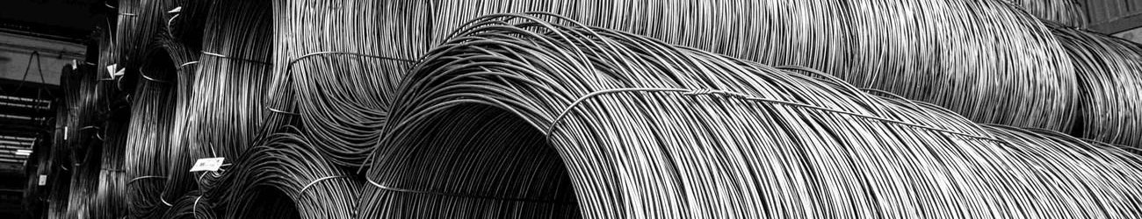
Coils for processing and wire drawing. 5.5–14 mm range.
Steel billets

Semi-finished products for rolling. The supplied dossier describes a B500WR reference, 150 × 150 mm section and 12 m ±30 mm length; current specification and export availability require confirmation.
Real product photographs from the supplied presentation dossier and its product documentation. They do not depict facilities owned by COTI.

Our Products – Feedstock and complementary products
Direct reduced iron – DRI / CDRI
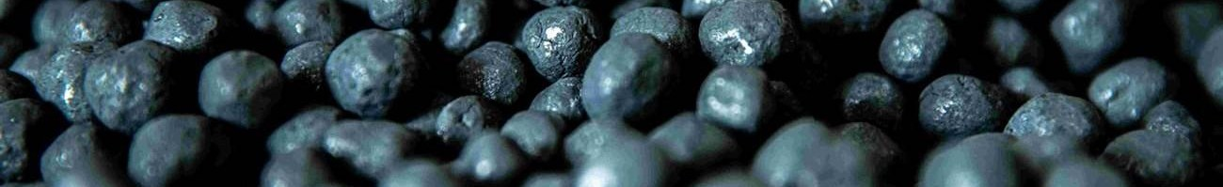
Pellet-form feedstock for steelmaking. The dossier states total Fe ≥ 89.50%, metallic Fe ≥ 84.20%, metallisation ≥ 94% and carbon 1.50–2.50%. Each lot and export availability require confirmation.
Calcined lime & dololime

Flux products used in steelmaking. The dossier describes a combined 280,000 t/year capacity primarily for the site's internal consumption; commercial export availability is not assumed.
DRI can reoxidise and react with water, releasing heat. Supply requires a safety data sheet, suitable packaging and transport procedures. COTI coordinates the requirements with qualified parties.
From feedstock to delivery
Direct reduced iron → electric arc furnace steelmaking → ladle refining → continuous billet casting → hot rolling → bars or coils → quality checks → identification and packaging → delivery. The exact scope depends on the product and order.
Why steel matters for energy projects
Oil and gas sites, power plants, renewable-energy installations and hydrogen facilities use steel in foundations, reinforced-concrete works, buildings and infrastructure. The rebar described here reinforces concrete; it does not replace pressure piping, pressure vessels or special steel grades governed by different specifications.
Plant visit, verification or meeting
COTI is available to arrange your reception at the plant in Algeria for a technical review, product inspection, quality-document verification or commercial meeting. Visits require an appointment, site authorisation and compliance with applicable safety and confidentiality requirements.

